Data Analytics with Tableau

Project name:- Measuring the pulse of prosperity:- An Index of Economic Freedom Analysis
Project ID:- LTVIP2026TMIDS72915
Project Mentor:-Varoodhini
Date:-
20 february 2026
Data visuals:-
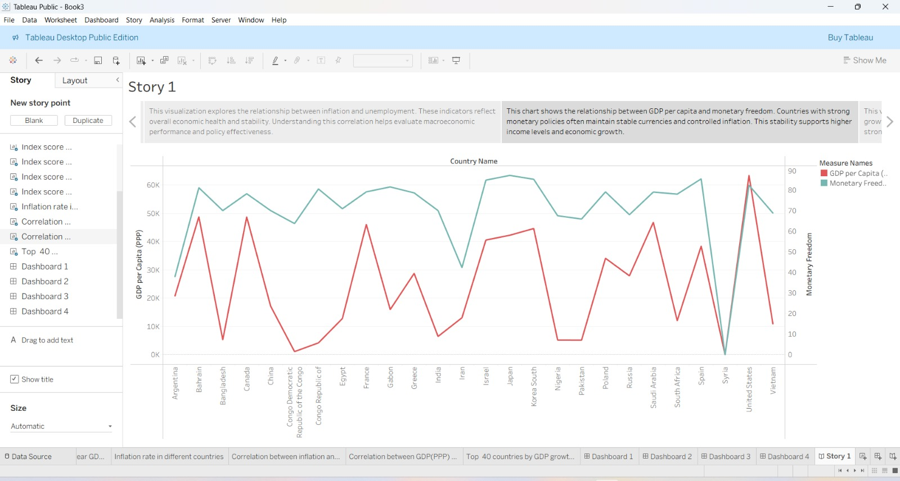

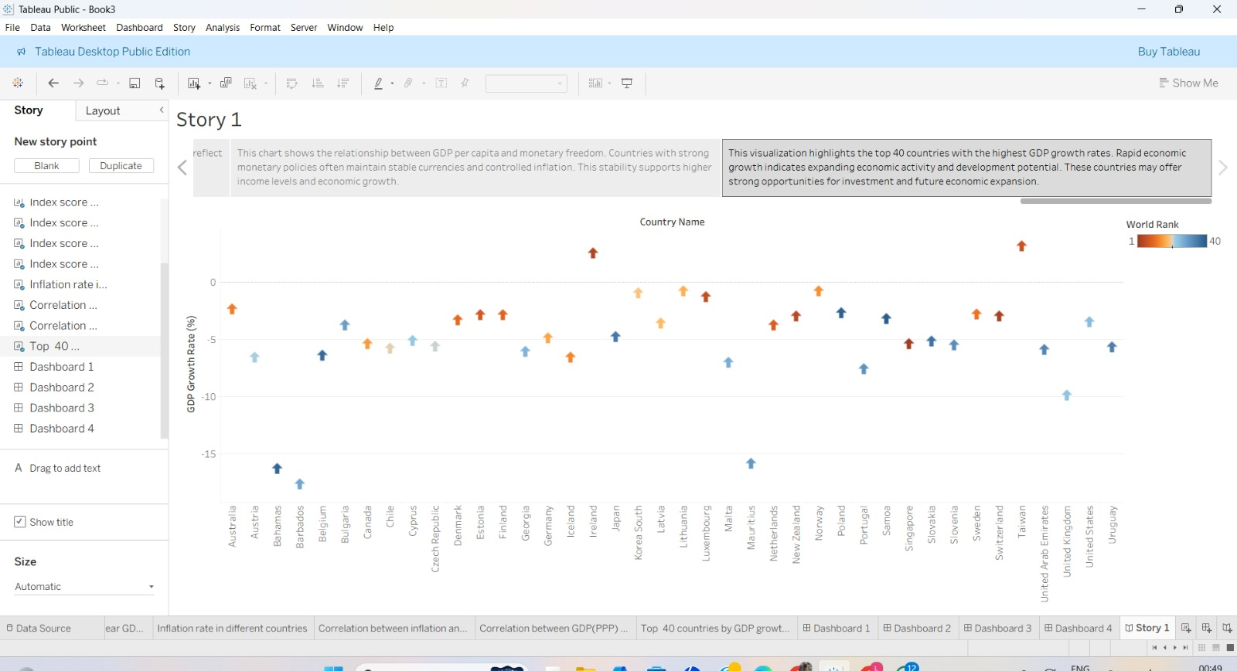

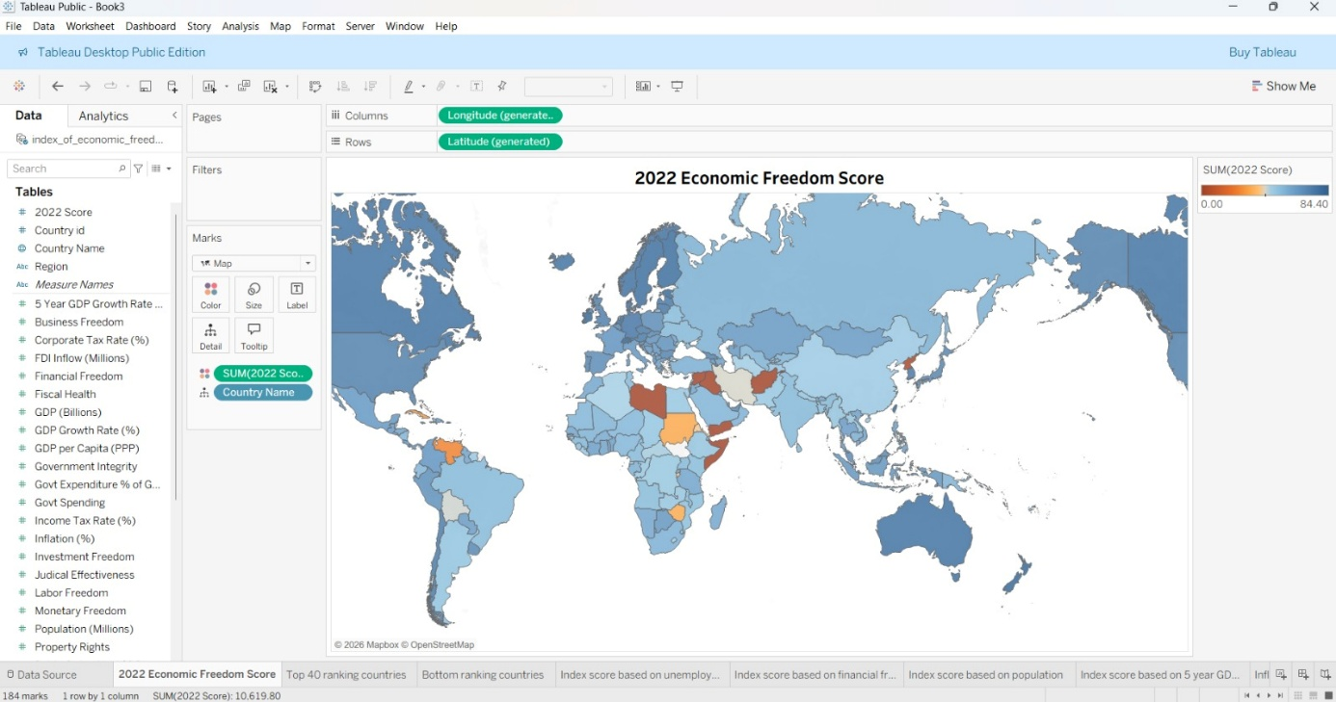

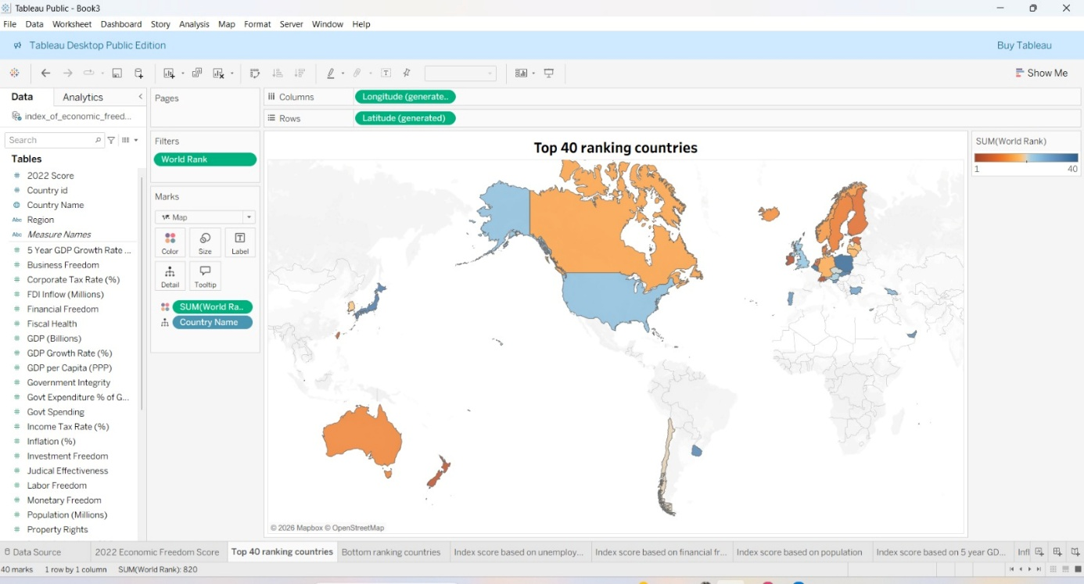

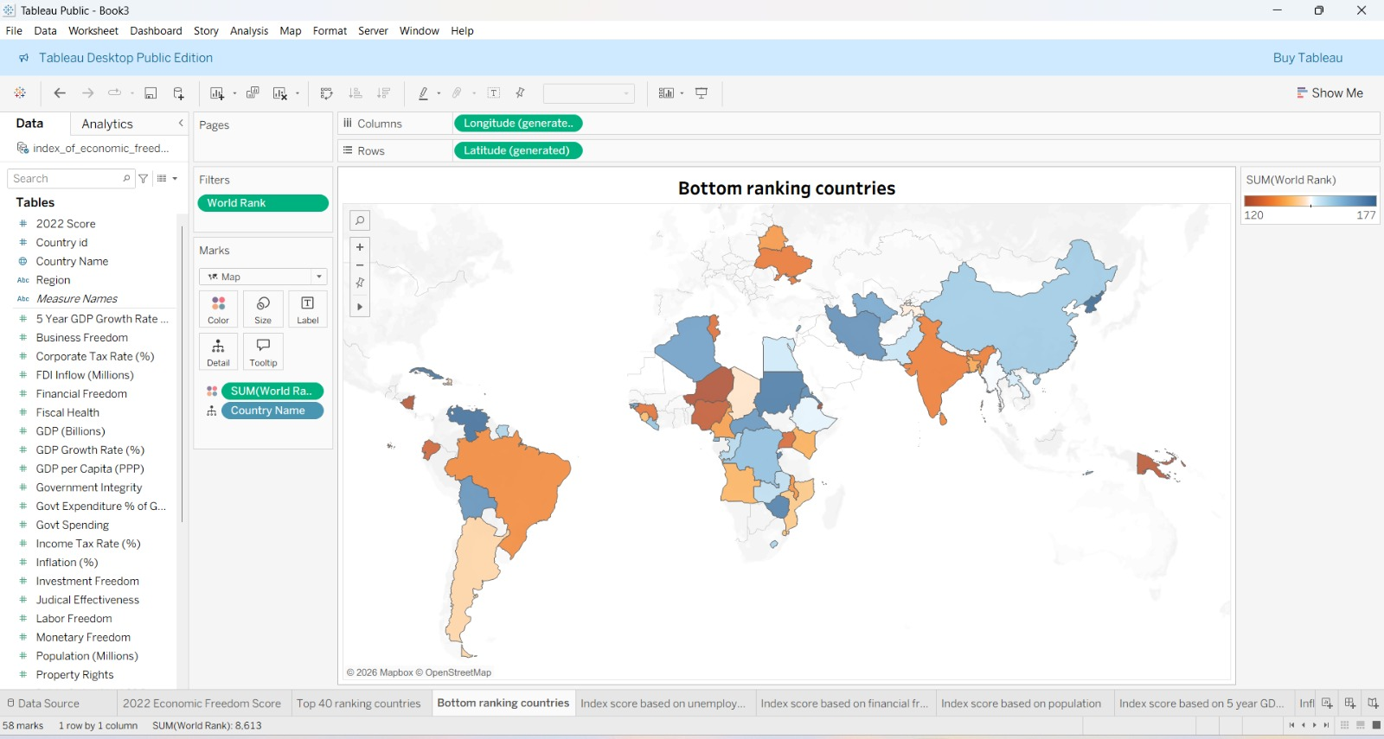

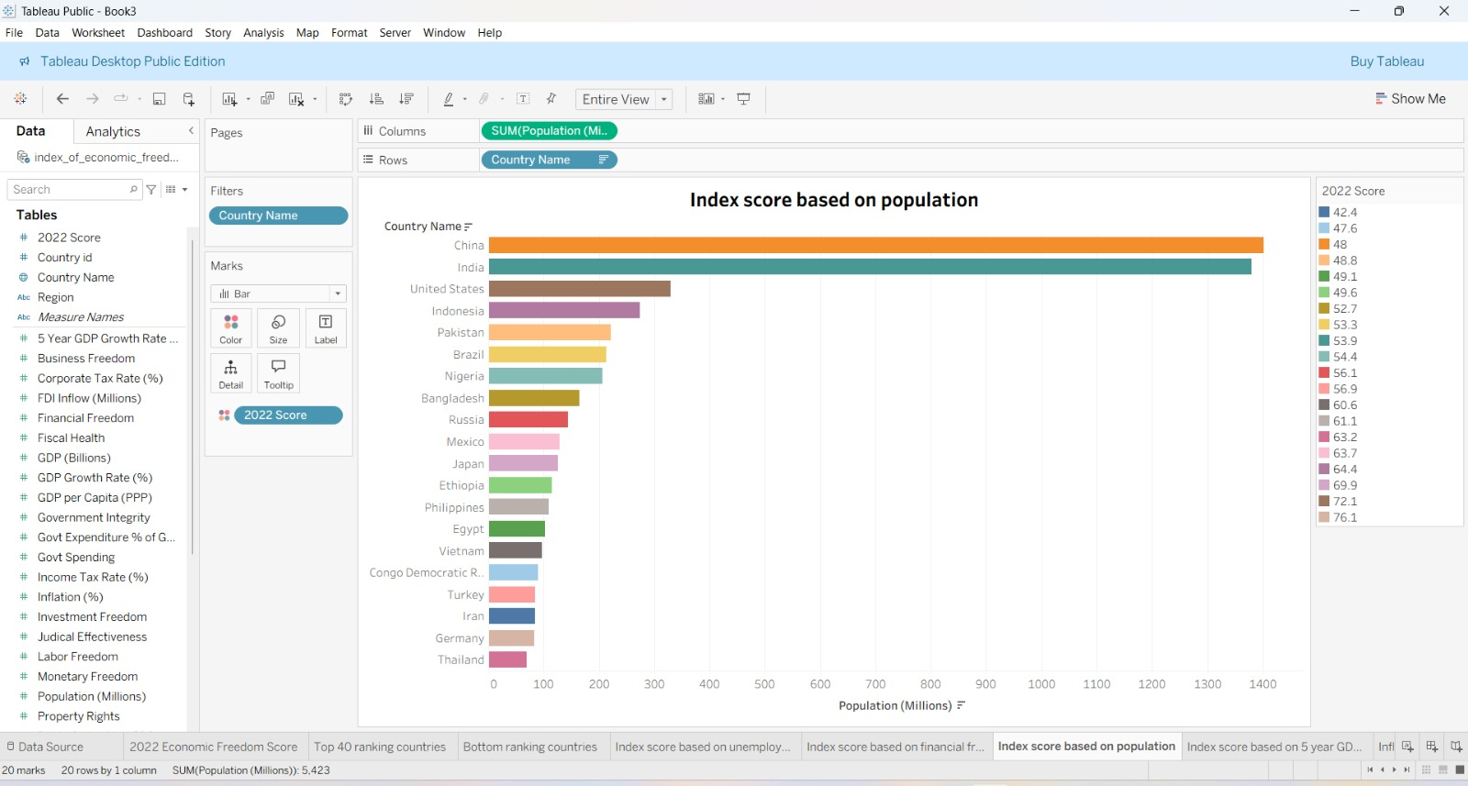

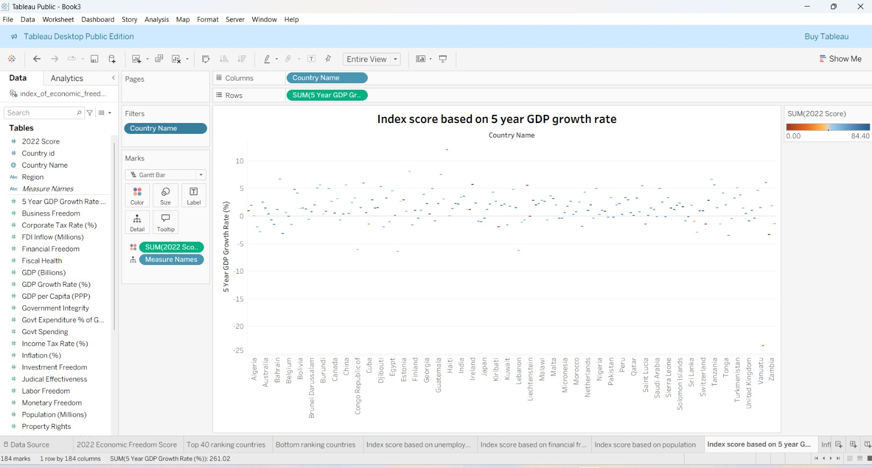

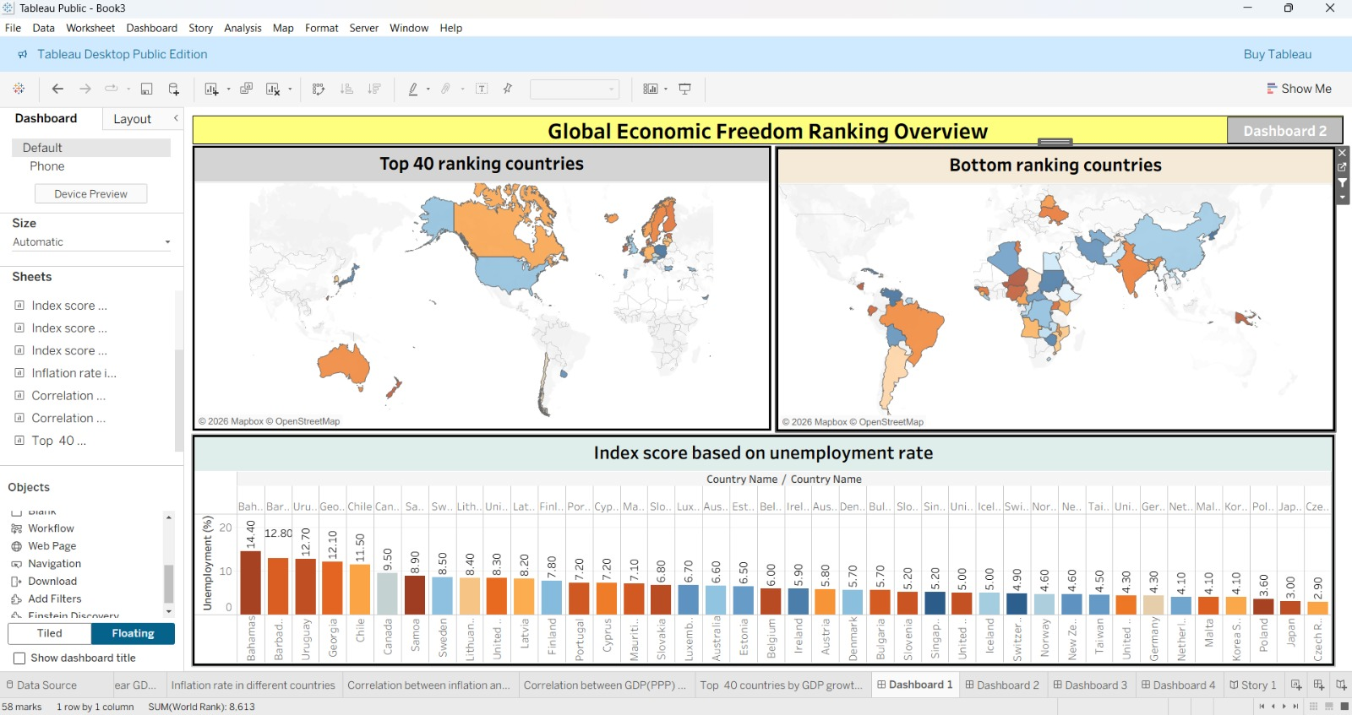

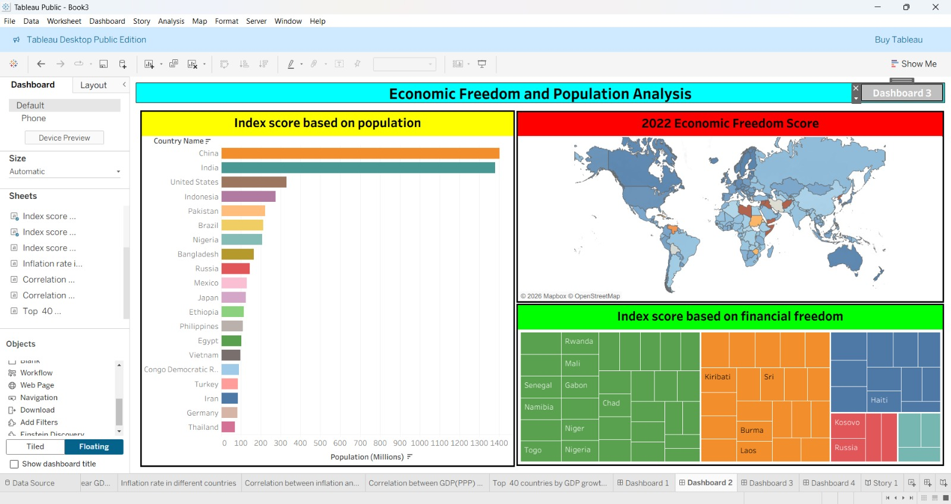

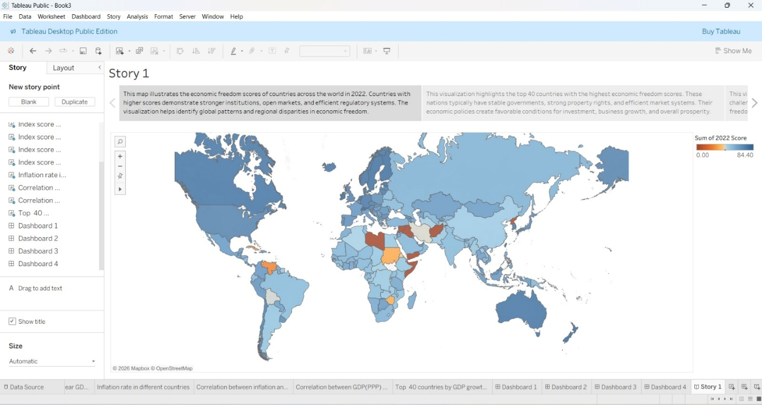

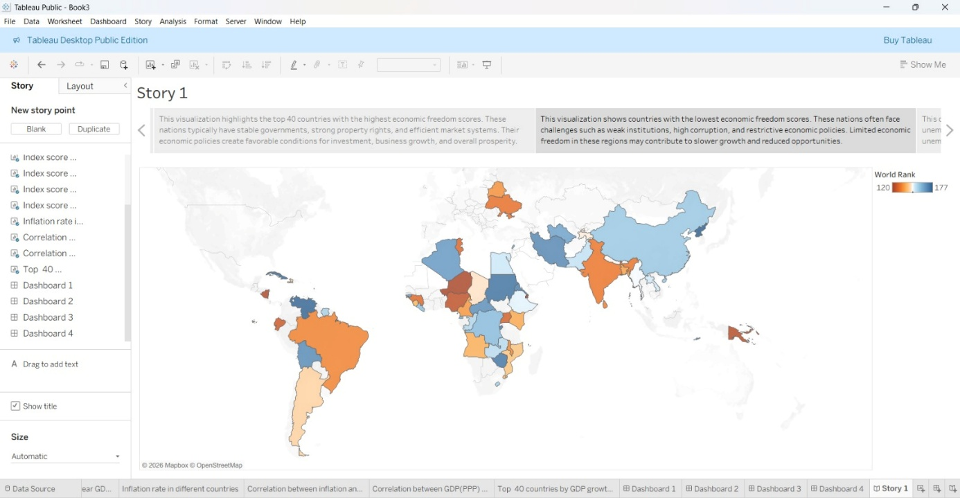

Data set link:-
- https://drive.google.com/file/d/1EBIa1LtM3Ni2Uh3nekLB6wt3263Q3NeX/view?usp=share_link
Tableau public link:-
- https://public.tableau.com/app/profile/kavya.sai2827

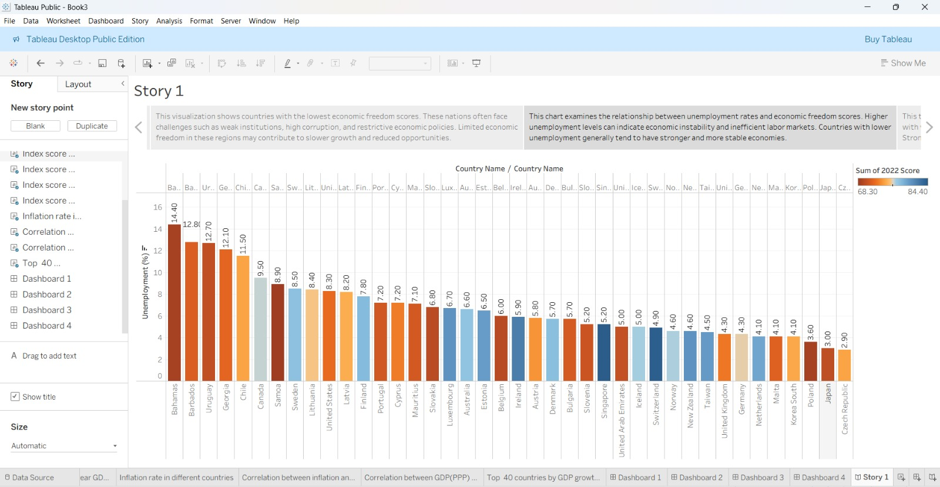

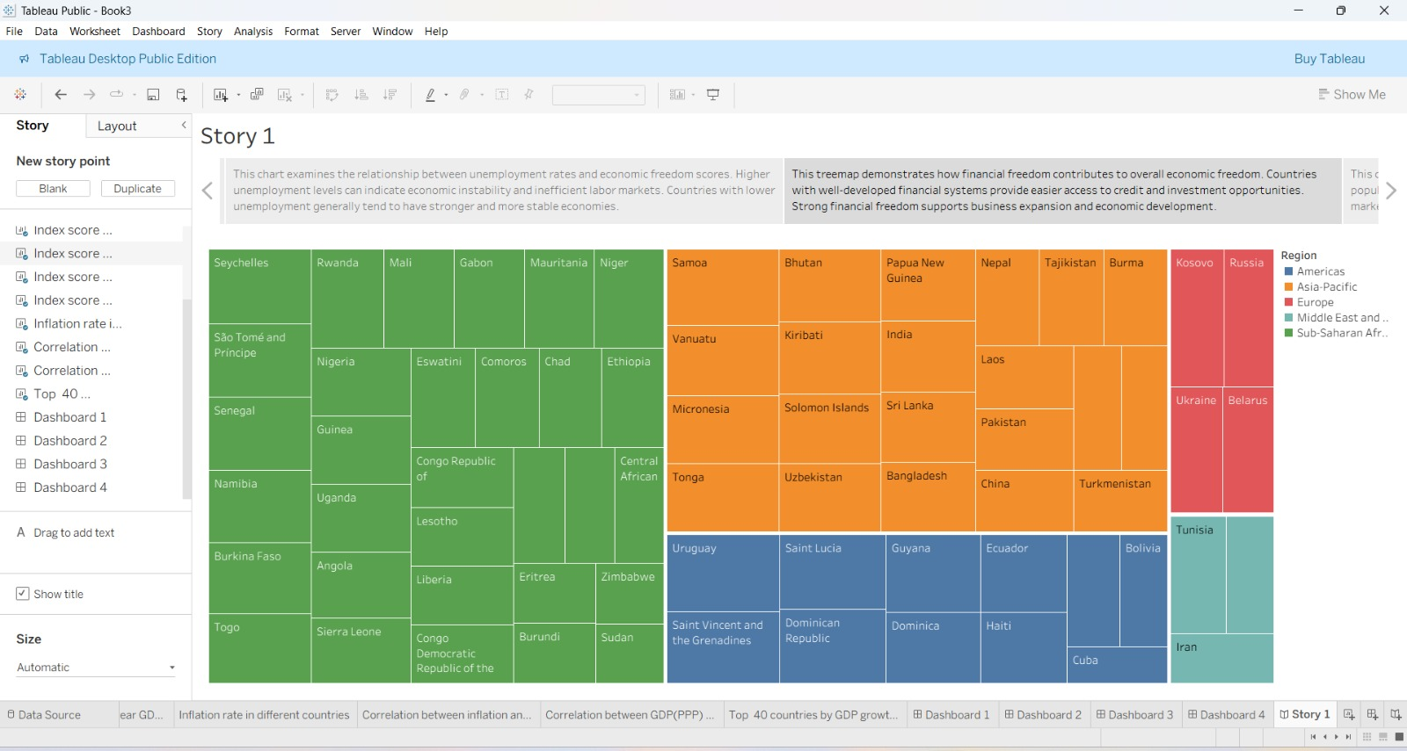

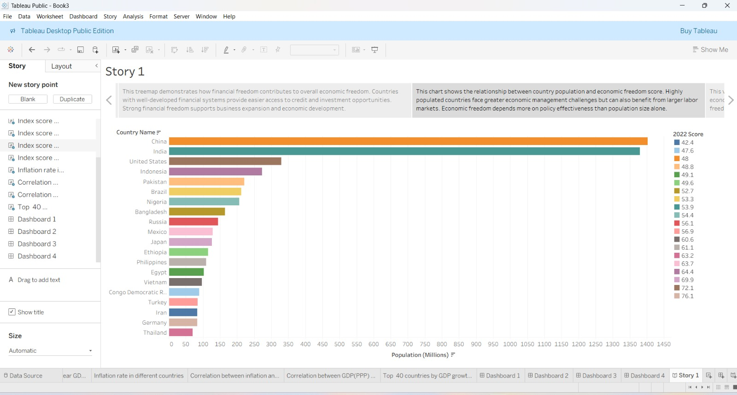

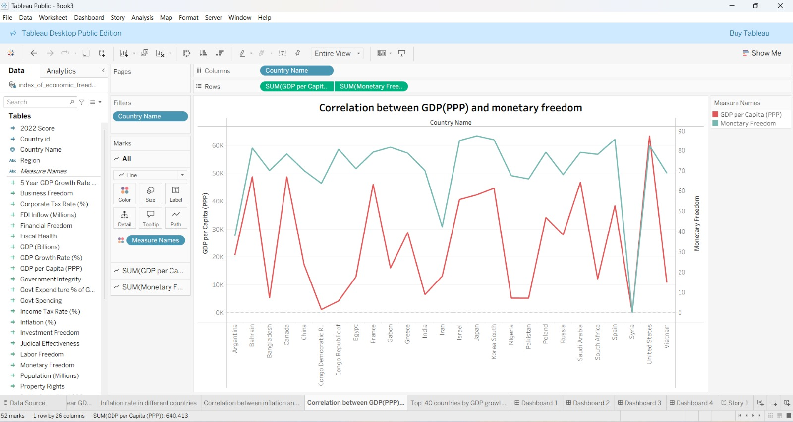

Demo link:-
https://drive.google.com/file/d/112EatZxl8xNVBg7Rv3CFDZ24hE3VNrix/view?usp=drivesdk

